Cisco Systems Session Border Controller (SBC) 23
with Software Release IOS XE 17.12
APCO Tracking Number 2319401

TDR Number: CIS-1824-001

Requirement: UCR 2013 Change 2, Section 2.25.1

Finding: MLPP CALL FAILS TO PRODUCE AUDIO UPON PREEMPTION

Description of product:
The Cisco Session Border Controller (SBC) facilitates IP to IP AS-SIP communications between session controllers (SC) that support the UCR Alternative B failover method and their end instruments, when traversing the UC Network. The SBC interfaces with DISN UC systems through an AS-SIP interface and provides IP to IP communications between edge (LSC/ESC) and core (Softswitch) segments in the UC network. Additional functions include AS-SIP Signaling and encryption services to allow end to end communications on the UC Network. This solution can also be combined with a Cisco Session Controller to provide both interworking and SBC capabilities. This SBC solution consists of the Cisco ISR 4000 series, ASR 1000 series, Catalyst 8000V, Catalyst 8200 Series and Catalyst 8300 Series of hardware platforms.

Problem Description:

Call string setup is achieved correctly; however, no audio is produced upon the preemption.

Condition of test:

Test Scenario:
A call C @ ROUTINE Precedence
A and C connect
B calls C @ PRIORITY Precedence

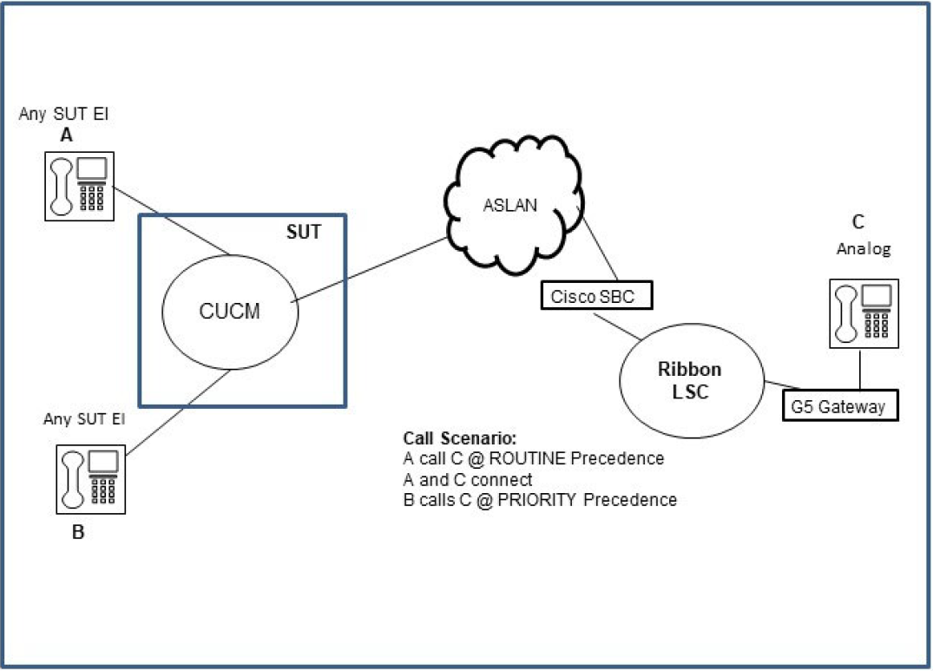

Test Result:
A and C both receive Precedence Notification Tone (PNT)
A and C go on hook
C rings @ Precedence cadence and goes off hook
B and C connect, but neither received any audio

Note: If either party does a hold off hold function, the audio is established.

Expected behavior:
After B and C connect, both parties should receive audio.

Components Affected: CISCO SBC23

Vendor Evaluation:

At this time Cisco has analyzed the issue and identified the port negotiation failure.

The issue is a Mismatch of point-to-point Audio/Media Streams. Found in Wireshark traces.

- Currently we see Cisco SBC sending an INVITE (SECOND CALL) with Audio Port 18386 to Ribbons Call Control on the red-side of the connection.
- However, we see Cisco SBC Listening on Port 18388.
- This creates a mismatch with audio, and can explain why MLPP was successfully setup, but no audio heard bi-directionally.
- *We do see the MLPP call string setup properly (MLPP was successful).
- We are opening a Case with our developers to understand the No Audio on this one call string.
- CISCO believes this one Call String is Minor corner case. All other MLPP calls works; and same call string works with Cisco SBC fronting REDCOM SLICE, NEC, Cisco ESC and Cisco SS. This is something between RIBBON Call Control and CISCO SBC, on one unique call string.

Vendor Plan of Action & Milestones:

- Cisco will provide a fix by Q4 FY2024.

